Skip to Main Content

This website was built on Wix. Create yours today.Get Started
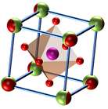

Home

About

Research

Publications

Contact

Vishal Kotha
Postdoctoral Researcher in Materials Chemistry

RESEARCH EXPERTISE
- Certified Expert in Transmission Electron Microscopy (TEM)
- Crystal Engineering (Size, Morphology, Composition)
- Synthesis (Electroplating, Hydrothermal & Molten-Salt)
- Crystal Structure Analysis: XRD (Rietveld Refinement) in conjuction with Electron Diffraction (TEM) analysis
- Electrocatalysis (Metal-Air Batteries: Perovskites, Electrolyzers: Chiral Metals)
- Organocatalysis (Selective Reduction of Chalcones)
- Photocatalysis (Water Purification)
- Nanofabrication (e-Beam Lithography)

Transferable Skills
- Project Management
- Teaching & Mentoring
- Academic Writing
- Teamwork & Collaboration

Welcome Message
​
Welcome to the captivating journey through the realm of materials chemistry. I'm Dr. Vishal Kotha, a passionate postdoctoral researcher committed to unraveling the secrets of materials science. Embark on this voyage with me as we explore the intricate world of novel materials, from perovskite metal oxides to chiral metals, all crafted with the vision of contributing to renewable energy and sustainable technologies.

Highlights
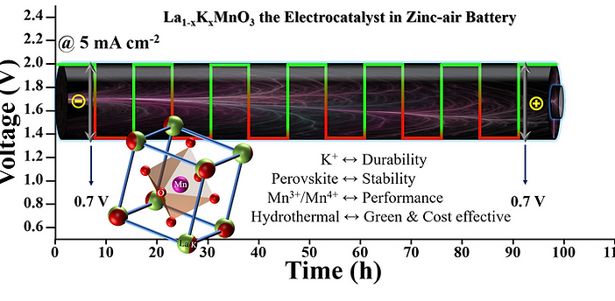

Potassium-Substituted LaMnO3 as a Highly Active and Exceptionally Stable Electrocatalyst toward Bifunctional Oxygen Reduction and Oxygen Evolution Reactions
ACS Appl. Energy Mater. 2022, 5 (6), 7297–7307
We designed a cost-effective, enduring perovskite oxide catalyst for efficient oxygen evolution and reduction. The catalyst, composed of potassium-substituted LaMnO3, demonstrates superior kinetics and stability in both reactions. In an alkaline environment, it exhibits a half-wave potential of 0.78 V for the oxygen reduction reaction (ORR) and a potential of 1.66 V at 10 mA cm−2 for the oxygen evolution reaction (OER). Remarkably, as a zinc−air battery electrode, it maintains stability over 1000 charge−discharge cycles without visible degradation.

Join my mailing list for updates on publications and events

First name
Last name
Email
Join

Berhampur, Odisha, India 760001
vishalkotha1@gmail.com
+91-9488 659 155
© February 2024 by Vishal Kotha. Powered and secured by Wix
Skip to Main Content

This website was built on Wix. Create yours today.Get Started


Home

About

Research

Publications

Contact



A Bit About Me
Ever since my childhood, I have been deeply fascinated by science. I have always believed that more passion is needed to pursue science than any other quality. I remember, even today, how excited I used to be to understand the nature and mechanism behind each and every concept being taught to me; and how I used to perform a lot of self-studies to educate myself about how things around me work. Unsurprisingly, this was what encouraged me to study the various synthetic pathways and characterization techniques behind the development of different morphologies in materials when most of the world research has been pivoted towards only the synthesis of newer materials in different dimensions.
​
With a broad interest in materials chemistry and a specific fascination with computational science, my primary focus will be pivoted on the study of synthesis mechanisms, engineering size-phase-morphology, and property-application research. I intend to align my future research interests with the emerging trend of developing new materials and mechanisms to synthesize and store green hydrogen. According to what I have learned thus far in my research, perovskite-structured materials would provide the stability and flexibility necessary for engineering the catalyst materials. I wish to investigate the various compositions and morphologies of these materials for exploring their interaction with H2. In addition, by developing novel synthesis techniques, I can produce highly porous perovskite materials, which, to my knowledge, has never been accomplished. These extremely porous perovskites will be used to store and transport green hydrogen. As these perovskites have not been widely utilized for conventional catalysis. Thus, I see ample opportunity in this field to pursue my curiosity. I am extremely curious to continue in this direction of resolving fundamental material science problems while simultaneously providing solutions to pressing global issues such as the energy crisis. In this regard, I am open to novel experimental approaches and characterisation techniques.

Work Experience

April 2023 – January 2024

July 2022 – April 2023

April 2022 – July 2022
Postdoctoral Fellow, Weizmann Institute of Science, Rehovot, Israel​
- Incorporation of chirality in metals by electrochemical methods and exploring its effect on electrochemical water splitting.
- Chiral Ni-Au system shown superior HER (Hydrogen Evolution Reaction) activity compared to gold and achiral counter parts.
- Chiral separation of organic impurities using Fe3O4 nanoparticles and their characterization using CD and chiral HPLC.
Postdoctoral Fellow, Indian Institute of Technology Bombay, Mumbai, India
- Effect of magnetic field on water electrolysis using the La2FeMnO6 catalyst that had been synthesized using low-temperature hydrothermal and molten-salt routes.
- Mechanochemical shear-induced nucleation and exfoliation of inorganic nanomaterials (graphene).
Research Associate, Indian Institute of Technology Bombay, Mumbai, India
- Low-temperature synthesis of double perovskite oxides and characterization of their electrocatalytic activity in zinc-air battery.

Education

April 2023 – January 2024

July 2022 – April 2023

April 2022 – July 2022
Postdoctoral Fellow, Weizmann Institute of Science, Rehovot, Israel​
- Incorporation of chirality in metals by electrochemical methods and exploring its effect on electrochemical water splitting.
- Chiral Ni-Au system shown superior HER (Hydrogen Evolution Reaction) activity compared to gold and achiral counter parts.
- Chiral separation of organic impurities using Fe3O4 nanoparticles and their characterization using CD and chiral HPLC.
Postdoctoral Fellow, Indian Institute of Technology Bombay, Mumbai, India
- Effect of magnetic field on water electrolysis using the La2FeMnO6 catalyst that had been synthesized using low-temperature hydrothermal and molten-salt routes.
- Mechanochemical shear-induced nucleation and exfoliation of inorganic nanomaterials (graphene).
Research Associate, Indian Institute of Technology Bombay, Mumbai, India
- Low-temperature synthesis of double perovskite oxides and characterization of their electrocatalytic activity in zinc-air battery.

Let's Get
Social


Join my mailing list for updates on publications and events
Top of Form
First name
Last name
Email
Join
Bottom of Form
Berhampur, Odisha, India 760001
vishalkotha1@gmail.com
+91-9488 659 155
© February 2024 by Vishal Kotha. Powered and secured by Wix
Skip to Main Content

This website was built on Wix. Create yours today.Get Started


Home

About

Research

Publications

Contact

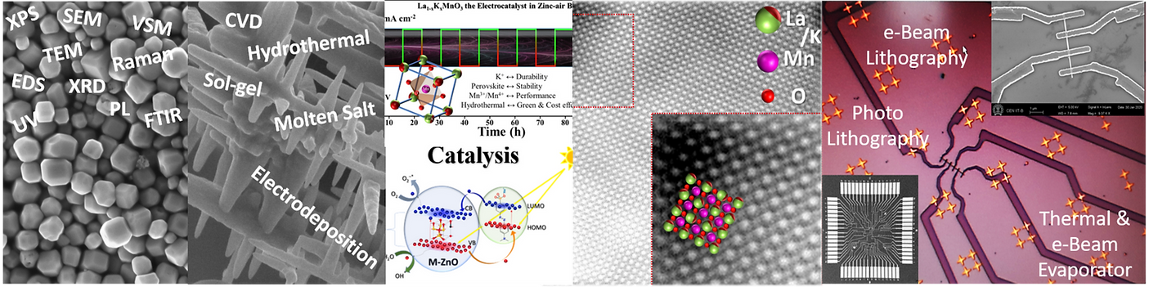
​

Overview
​
Welcome to the heart of my scientific exploration - the Advanced Materials Lab. Here, we manipulate electrons and spins within layered materials like oxides, two-dimensional materials, and heterostructures. Our goal is to pioneer the next wave of electrolyzers and catalysis platforms, contributing to next-generation batteries, catalysis/sensing platforms, and materials for neuromorphic and quantum computing.​
​

Approach
​
Our research is a synergistic blend of experimental and computational techniques. From electrochemical assays to advanced microscopy, we decode fundamental mechanisms from the atomic to the system level. By bridging materials chemistry and condensed matter physics, we aim to address pressing global challenges, particularly climate change and energy accessibility.
​

Focus Areas
​
- Materials for Renewable Energy: We focus on lanthanum-based perovskite oxides, aiming to unlock their potential in renewable energy applications.
- Low-Dimensional Materials: Our exploration includes oxides, two-dimensional materials, and heterostructures, where we manipulate electrons and spins for diverse applications.
- Catalysis and Electrolyzers: Our efforts extend to developing catalysis platforms and electrolyzers that contribute to cleaner and sustainable energy solutions.
​

Passion for Sustainability
​
Driven by a passion for sustainability, our research aligns with the urgent need to combat climate change. We strive to discover materials that not only offer high performance but are also environmentally friendly. Join us in this quest for equitable and sustainable energy solutions that can shape a brighter future for our planet. Explore our ongoing projects, dive into the world of molecular electronics, and witness the transformative power of materials chemistry.

Join my mailing list for updates on publications and events

First name
Last name
Email
Join

Berhampur, Odisha, India 760001
vishalkotha1@gmail.com
+91-9488 659 155
© February 2024 by Vishal Kotha. Powered and secured by Wix
Skip to Main Content

This website was built on Wix. Create yours today.Get Started


Home

About

Research

Publications

Contact

Formative Years at Pondicherry University
Formative Years at Pondicherry UniversityFormative Years at Pondicherry University

Mastering the Microcosm
Mastering the MicrocosmMastering the Microcosm


My journey into the captivating realm of advanced computational material chemistry began during my master's program at Pondicherry University, India. Under the mentorship of Dr. M. M. Balakrishna Rajan, I embarked on a transformative exploration of materials at the microscopic level.
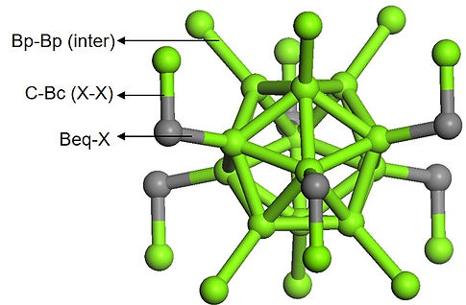

Boron Carbide Under the DFT Lens
My master's research focused on utilizing Density Functional Theory (DFT) to unravel the enigmatic failure mechanism of Boron Carbide (B4C) at high pressures. The study aimed to identify weak bonds susceptible to high pressure, potentially leading to structural modifications indicative of phase transitions.

Toolkit of Computational Alchemy
In pursuit of this mission, I harnessed the power of sophisticated software tools. CASTEP and VASP were instrumental for geometry optimization of materials, GAUSSIAN facilitated molecular models, while LOBSTER and YAeHMOP were employed for bonding analysis in extended structures.
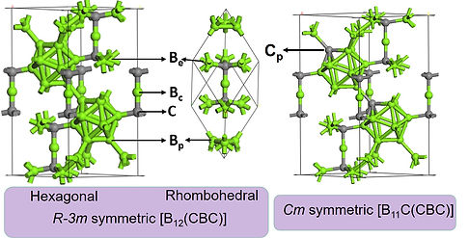
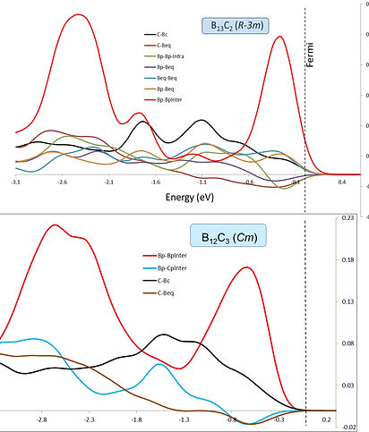

Connecting Computational Threads
The most enthralling aspect of this computational odyssey was the challenge of extracting chemical meaning from computations. Each computational thread, woven through different stages, converged to unveil a generalized picture. Navigating through diverse outcomes at various stages marked the most challenging yet gratifying moments.

Synthesis of Knowledge and Insight
The fusion of theoretical computations with practical implications was a hallmark of my master's journey. From unraveling the secrets of Boron Carbide's behavior under extreme conditions to connecting computational insights, the experience laid the foundation for a nuanced understanding of materials at the molecular level.
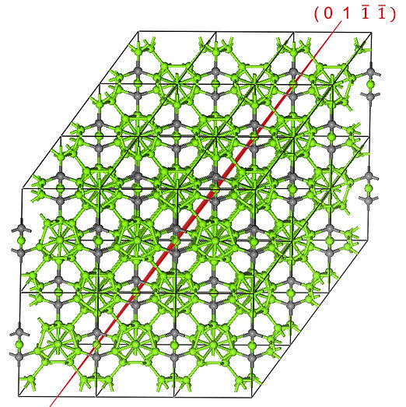

Abstract
AbstractAbstract




Thesis
ThesisThesis




Poster
PosterPoster




Building a Strong Analytical Foundation
The master's program not only equipped me with a deep understanding of computational methodologies but also fostered a strong analytical foundation. Navigating the intricate landscape of materials at the atomic and molecular levels laid the groundwork for my future forays into materials science.

Pondicherry University - A Crucible of Learning
My tenure at Pondicherry University was more than an academic pursuit; it was a transformative experience in a crucible of learning. The institution's commitment to academic excellence and research laid the groundwork for my subsequent doctoral journey.
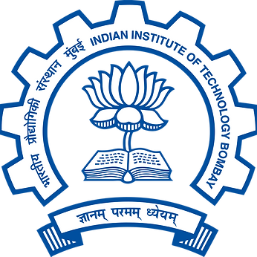

A Prelude to Doctoral Exploration
The master's program was not just a prelude to my doctoral exploration but a critical chapter that shaped my approach to materials science. Armed with computational alchemy and a thirst for unraveling material mysteries, I transitioned to the next phase of my academic journey at IIT Bombay.

Join my mailing list for updates on publications and events
Top of Form
First name
Last name
Email
Join
Bottom of Form
Berhampur, Odisha, India 760001
vishalkotha1@gmail.com
+91-9488 659 155
© February 2024 by Vishal Kotha. Powered and secured by Wix

